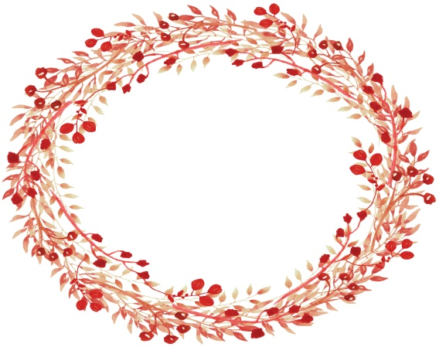
St. Andrew
Christmas
Novena

Hail and blessed be the hour and moment In which the Son of God was born Of the most pure Virgin Mary, at midnight, in Bethlehem, in the piercing cold. In that hour vouchsafe, I beseech Thee, O my God, to hear my prayer and grant my desires,
[here mention your request]
through the merits of Our Saviour Jesus Christ, and of His blessed Mother. Amen.
*to be said 15 times a day from November 30th until Christmas Day

The Littlest Way

