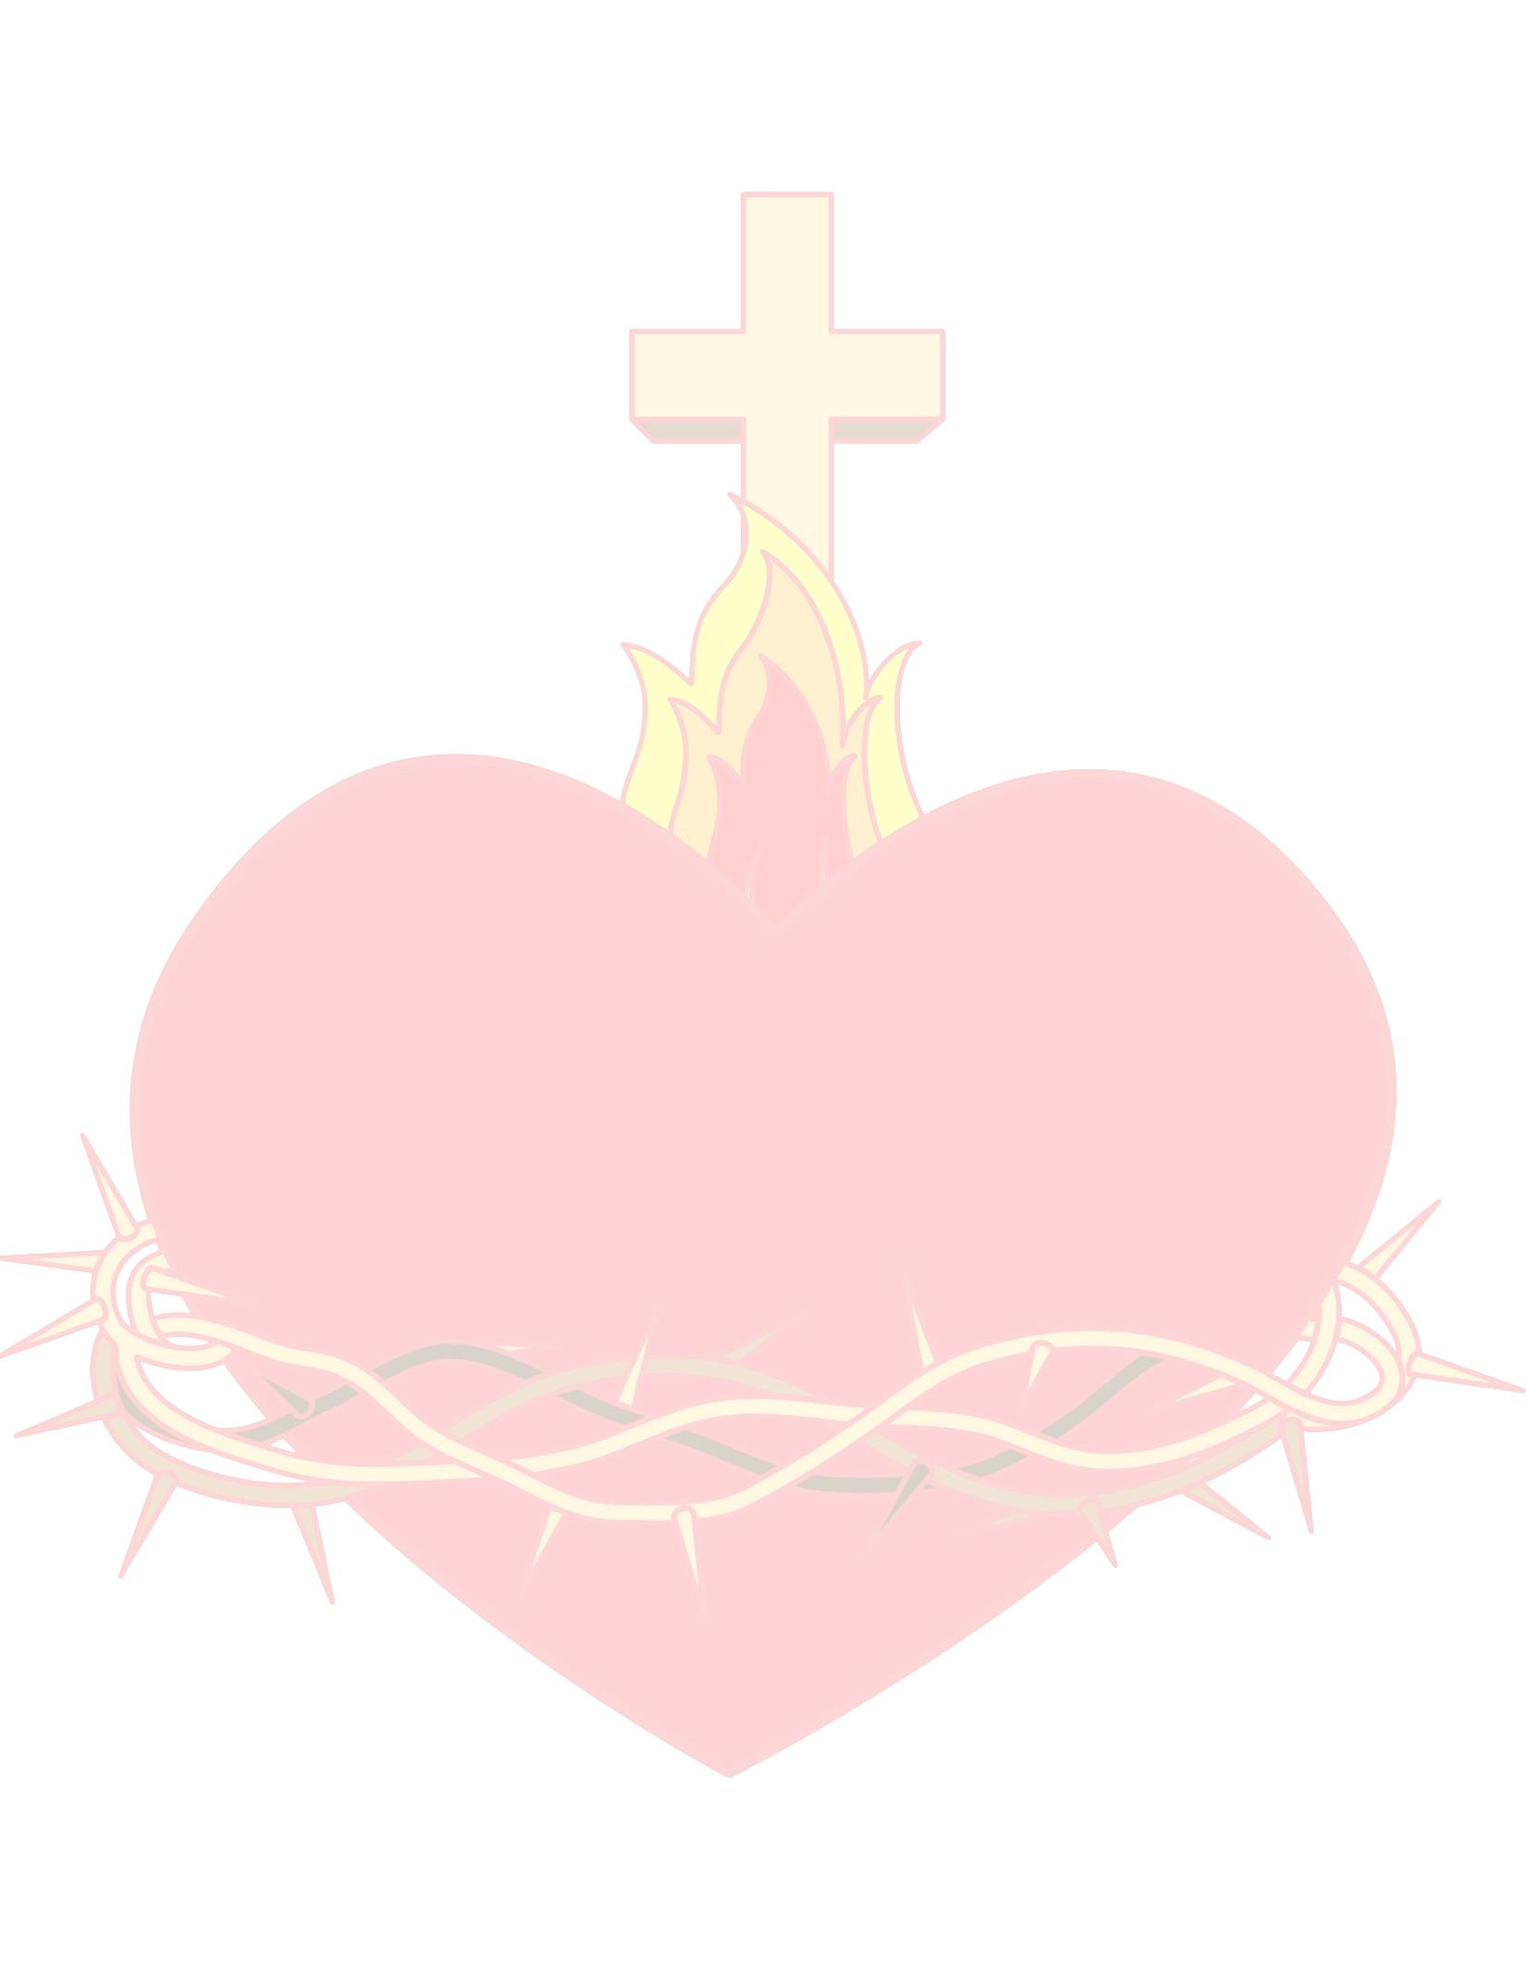
21 Days of Mercy
A Catholic Scripture Writing Plan
Day 1 Tobit 3:2
Day 2 Micah 7:18
Day 3 Wisdom 3:9
Day 4 Lamentations 3:22-23
Day 5 Sirach 2:11
Day 6 Colossians 3:12
Day 7 Sirach 35:20
Day 8 Ephesians 2:4-5
Day 9 1 Maccabees 4:24
Day 10 Hebrews 4:16
Day 11 2 Maccabees 6:16
Day 12 Tobit 8:17
Day 13 2 Maccabees 7:23
Day 14 Sirach 51:29
Day 15 2 Maccabees 11:10
Day 16 Wisdom 11:23
Day 17 Judith 16:15
Day 18 Wisdom 15:1
Day 19 Sirach 29:1
Day 20 Luke 6:36
Day 21 Wisdom 4:15

Do not let the past disturb you, just leave everything in the Sacred Heart and begin again with joy.
– St. Teresa of Calcutta

